Creating and Applying an ACL - Worksheet

In this project, you will create an ACL for VLAN 30 to accomplish the tasks given in the project. This project can be completed is as little as 1 minute. It is not expected to take longer than 30. There is an opportunity for 10 bonus points in this project.
Here is the information you will need for the project:
IPv4 Assignments:
PC Name | VLAN Name | VLAN Configuration
Sales 1 | Sales | 192.168.1.10
Marketing 1 | Marketing | 192.168.2.10
Admin 1 | Admin | 192.168.3.10
Sales 2 | Sales | 192.168.1.20
Marketing 2 | Marketing | 192.168.2.20
Admin 2 | Admin | 192.168.2.20
Sales 3 | Sales | 192.168.3.10
Marketing 3 | Marketing | 192.168.3.20
Admin 3 | Admin | 192.168.3.30
Provo DNS |  | 172.16.0.6
Provo Net Admin |  | 172.16.0.5
www.company.internal |  | 172.168.0.3
www.ralph.com |  | 198.168.5.2

VLAN Information:
VLAN Information | Port Assignments
1 Management | 13-16
10 Sales | 1 – 4
20 Marketing | 5 - 8
30 Admin | 9 – 12

Provo Router:
Interface | VLAN | IP Address | Encapsulation
gi0/0 | N/A | no ip address | none
gi0/0.1 | Sales | 192.168.1.1 | dot1q
gi0/0.2 | Marketing | 192.168.2.1 | dot1q
gi0/0.3 | Admin | 192.168.3.1 | dot1q
gi0/0.4 | VLAN 1 | 192.168.4.1 | dot1q
gi1/0 |  | 172.16.0.1
s2/0 |  | 198.3.24.4

 | Points Possible | Points Awarded
- Open Creating_and_Applying_an_ACL_Student_Project.pkt.
- Open Admin 3 and verify that you can ping:
  - Simulated Internet (198.168.5.2)
  - Provo Network Admin (172.16.0.5)
  - Sales 2 (192.168.1.20)
  - Marketing 1 (192.168.2.10)

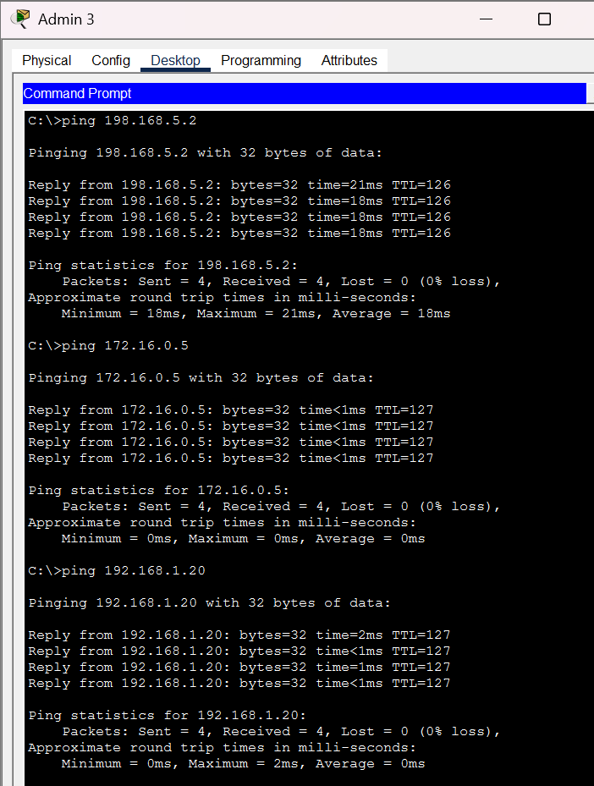  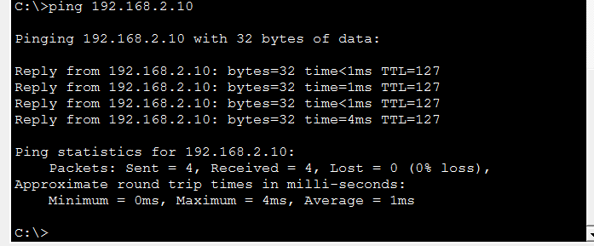 | 1
- Open the web browser and access www.company.internal
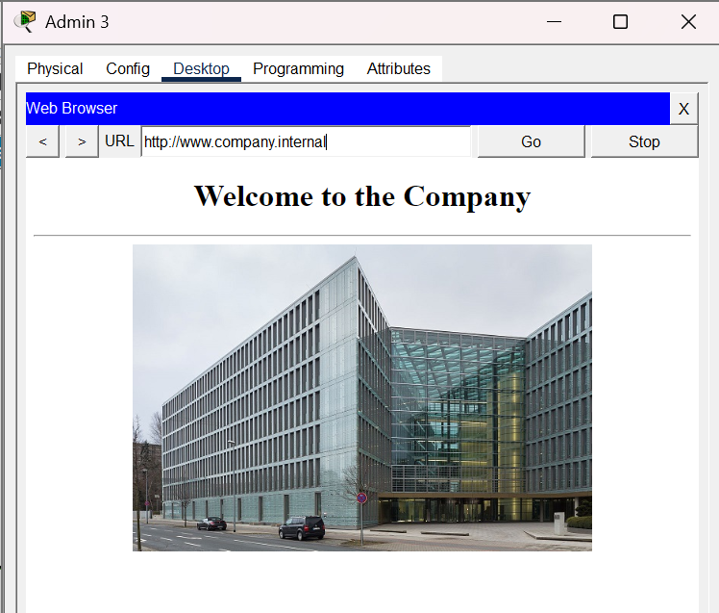 | 1
- Open the Provo router and create ACL 130. Take a snip of the created ACL (show access-list)
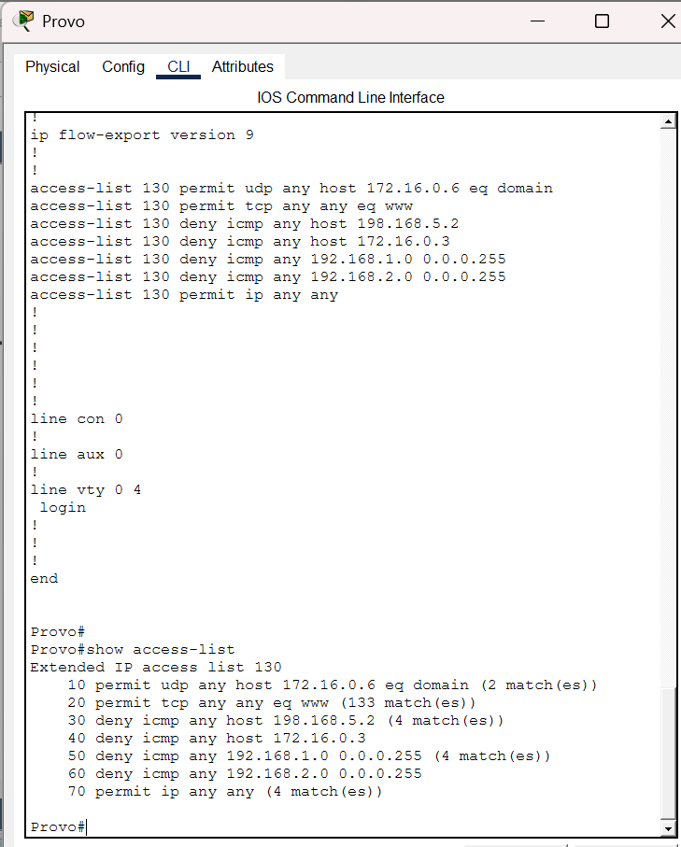 | 2
- Apply the ACL to the appropriate interface and direction. Take a snip of the running configuration showing the ACL applied to the interface.
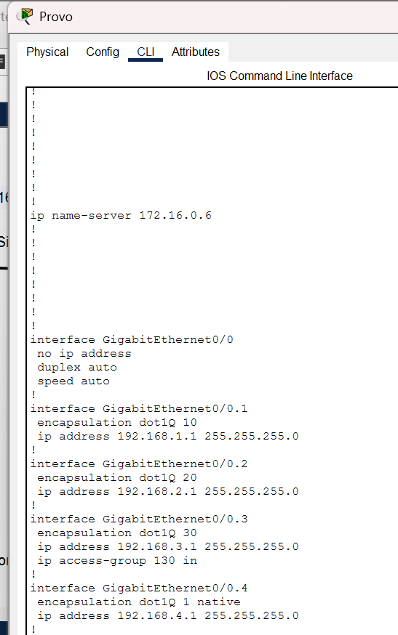 | 2
- Attempt to ping the Internet (198.168.5.2). It should fail
- Attempt to ping the Provo DNS (172.16.0.6). It should succeed
- Post snip of the ping results below.
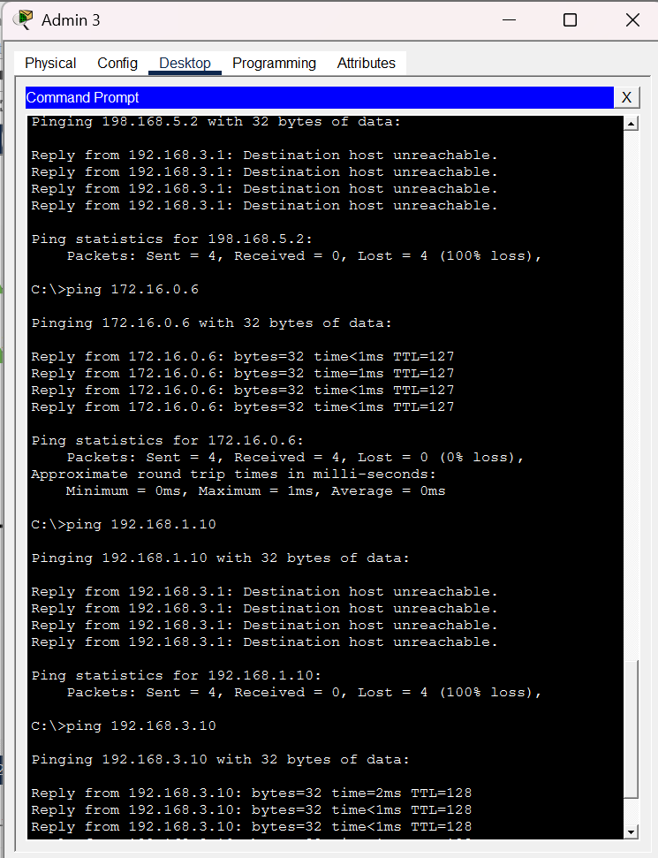 | 1
- Attempt to ping Sales 1 (192.168.1.10). It should fail
- Attempt to ping Admin 1 (192.168.3.10). It should succeed
- Paste the ping results below.
 | 1
- Open the Admin 3 Web Browser and access www.ralph.com. Paste results below.
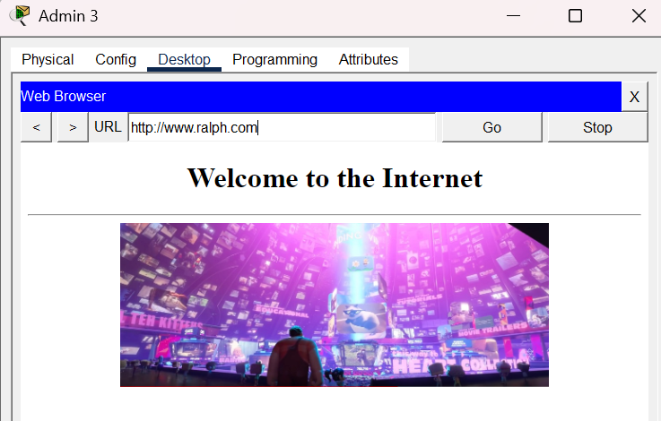 | 2
- BONUS! Open a ssh session between Provo Network Admin and the Team3 switch.
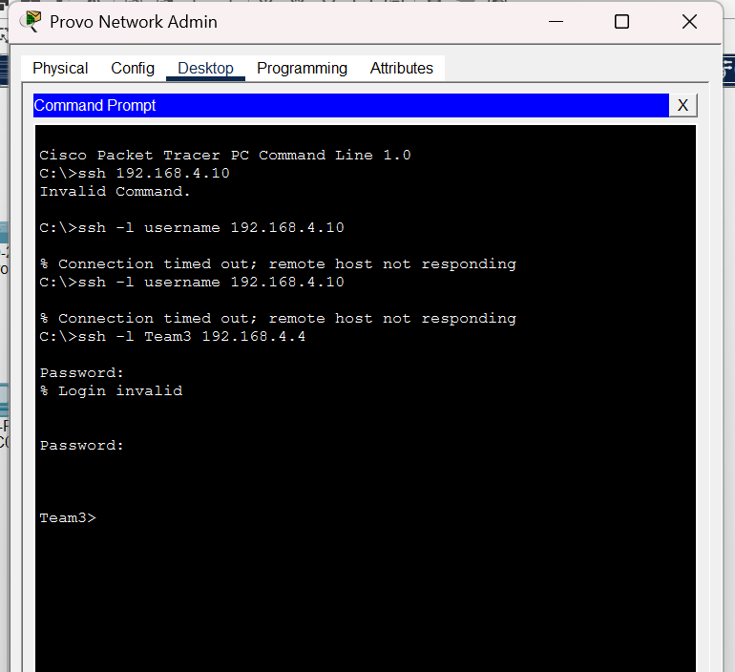 | 10
Points | 10
Bonus Points | 10
Total Points | 20

